# Simple Articles

Create a Web page (HTML5 + CSS3 + images) that looks and behaves like the screenshot below:

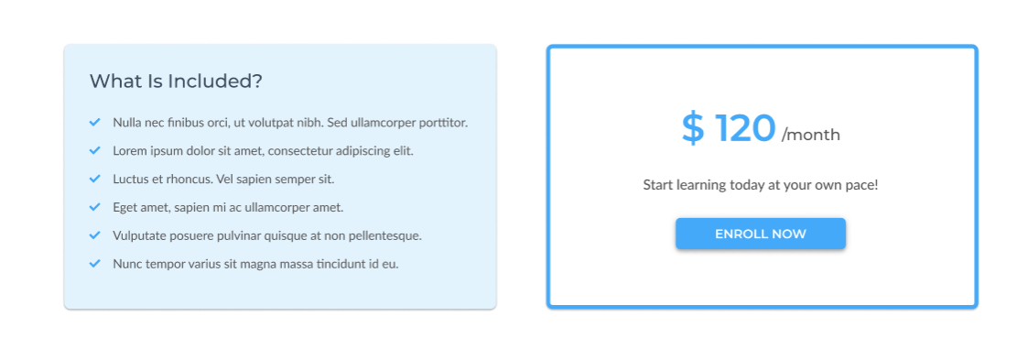

You are given the above screenshots + all required images.

### Output

The output should be valid **HTML5** + **CSS3** + **images** that implement the above web page.

### Constraints

* Use font 'Montserrat' for the heading and the price element
* Use font 'Lato' for the text
* The site should open correctly in the latest version of Chrome
* Pixel-perfect implementation is **NOT** required

# Photography

You are given an unresponsive website (**HTML** + **CSS** + images). Your task is to **make the site responsive**.

The site layout should change according to the browser viewport / screen size.

You need to implement 1 layout: **width <= 600px**. The figures below represent this layout:

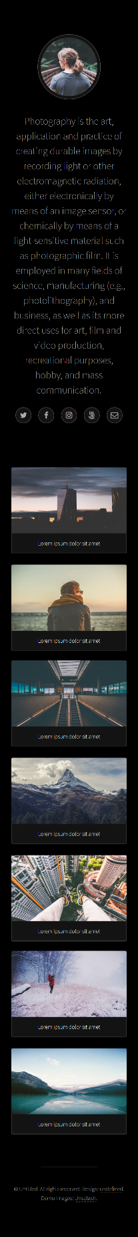

## Output

The output should be valid **HTML5** + **CSS3** + **images** that implement the above responsive site.

## Constraints

* You are **NOT** allowed to change the given **HTML** and **CSS**
* Pixel - perfect implementation is **NOT** required

# Certificates Landing Page

Create a Web page (HTML5 + CSS3 + images) that looks and behaves like the screenshot below:

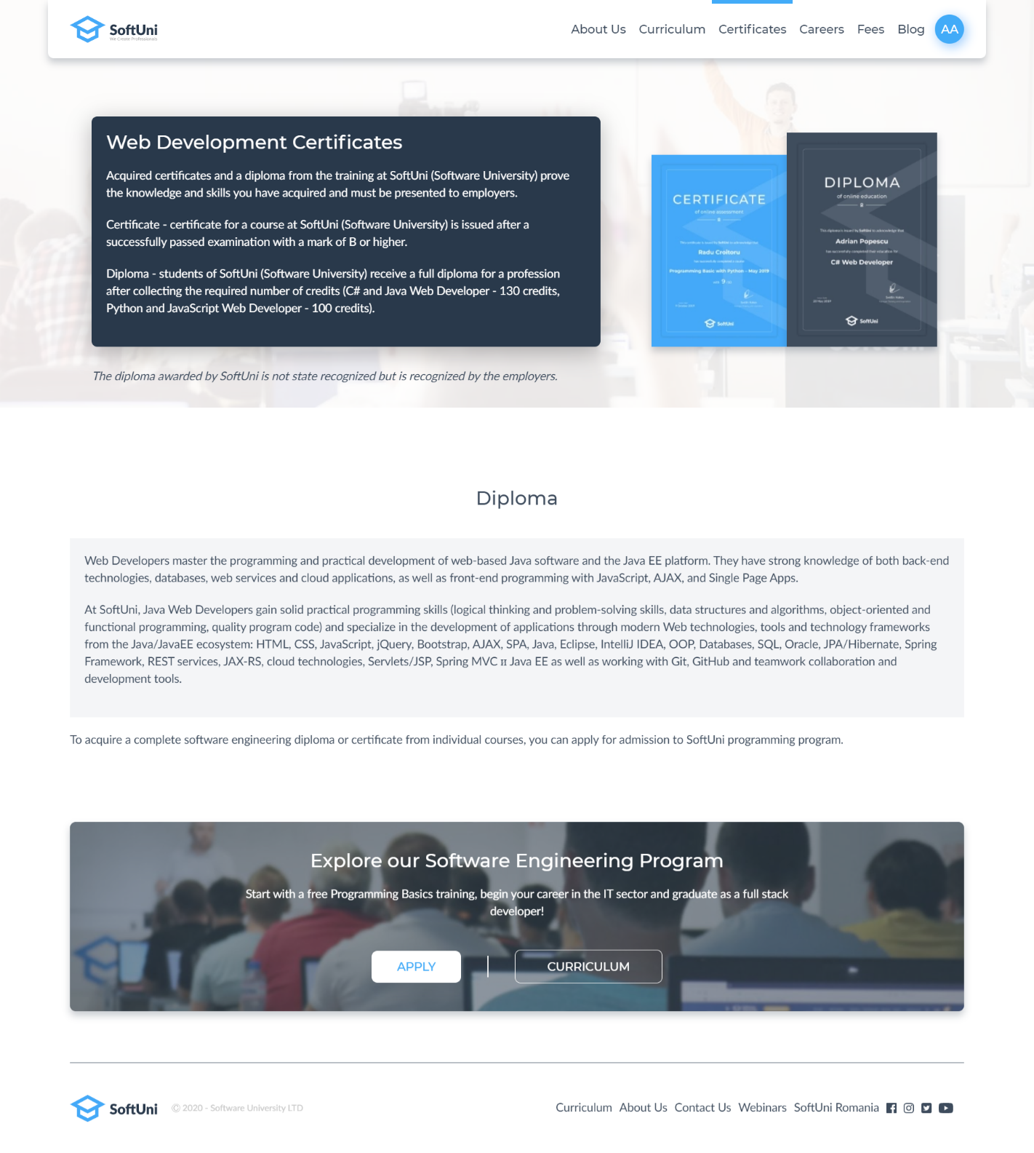

You are given the above screenshots + all required images.

### Output

The output should be valid **HTML5** + **CSS3** + **images** that implement the above web page.

### Constraints

* Use font 'Montserrat' for the heading
* Use font 'Lato' for the text
* The site should open correctly in the latest version of Chrome
* Pixel-perfect implementation is **NOT** required